**MORNING STAR SCHOOL**

**ACADEMIC SESSION 2024-25**

**HOLIDAY HOMEWORK**

**GENERAL INSTRUCTIONS**

⭐The assignment should be done as per the instructions given.

⭐It should be neatly labelled with your name, class and section mentioned clearly.

⭐The last date of submission of holiday assignment is 5thJuly 2024.

⭐Students are requested to do a lot of reading of books related to their stream & newspapers.

⭐ Prepare yourself for the Periodic Test-I which is going to be held in the month of July.

**Holiday homework is intended to make students independent and enhance their skills and capabilities. Holiday homework helps to keep students on track and keep their brains ticking.**

**Subject:-EVS CLASS-V**

1. Write four lines on a family get-together that you have attended recently, with the date, time, and place.
2. Learn everything done in your EVS notebook and textbook.
3. Help your mother in household activities like folding clothes, arranging groceries and other chores.

**(ASK YOUR PARENTS TO WRITE THEIR FEEDBACK ABOUT YOUR WORK IN YOUR NOTEBOOK)**

1. What important lessons do the team games teach a person?

(Write in five lines)

**WORKSHEET**

1. 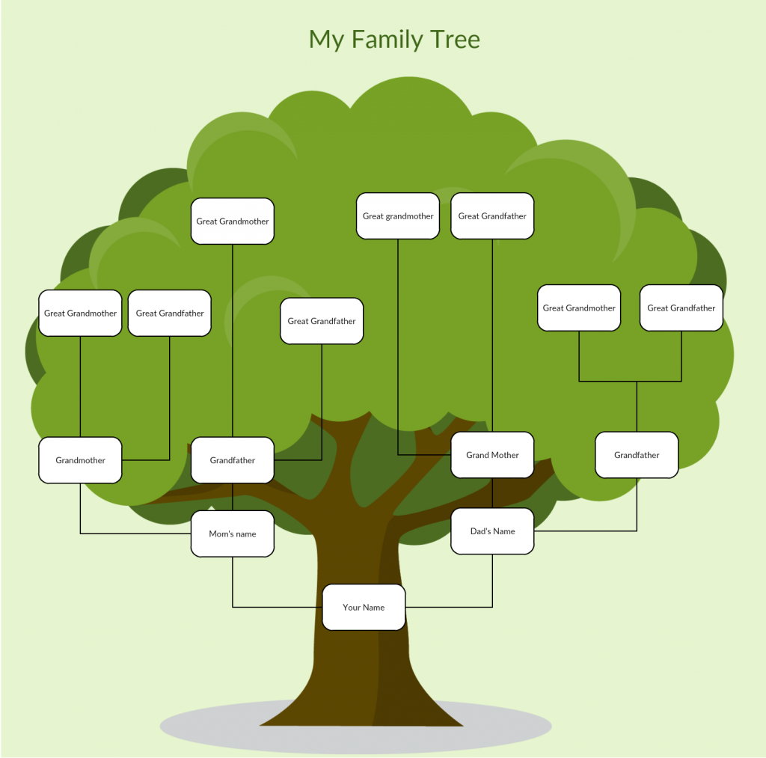Complete the given activity by pasting photographs or hand- drawn pictures of your family members in the family tree attached below.

**Subject:-ENGLISH CLASS-V**

1. Practice one page of handwriting daily.
2. Learn all the work done in your notebook.
3. Read the English E-newspaper daily and identify the difficult words, find their meaning from the dictionary. (at least 5 words daily)
4. Write 10 sentences on your own using helping verbs (eg. is, am, are, was, were, will, shall, have, has etc.) on an A4 size sheet.
5. Collect information on any two of the following personalities.

* Deepa Malik- Athlete.
* Mother Teresa- Social worker.
* Saina Nehwal- Badminton Player.
* Medha Patkar- Social Activist.

*Paste pictures , write about their achievements on a chart paper.

***WORKSHEET-1***

**Question 1. Sort these nouns in their respective types:-**

Taj Mahal, City, Apple, Narendra, Fruit, Team, Agra, Swarm, Car, Office, Colony, Zoo, Gwalior, Jury, Audience, Table, Coffee, Glass, Room, Bathroom, Rekha , Country, Galaxy, Mountain, Kerala, Plantation.

|  |  |  |
| --- | --- | --- |
| **Common nouns** | **Proper nouns** | **Collective nouns** |
|  |  |  |
|  |  |  |
|  |  |  |
|  |  |  |
|  |  |  |
|  |  |  |
|  |  |  |

**Question 2. Rewrite these sentences by changing masculine noun to feminine and vice-versa.**

1. Richa has three brothers.
2. The farmer bought some hens.
3. His grandmother is a teacher.
4. The queen sits on the throne.

**Question 3. Complete the sentences by using the adjectives given in the bracket.**

(lazy, black, sufficient, kind, costly, green)

* I have________ money to spend today.
* She is a _______ lady.
* The _______ cat is sleeping on the couch.
* He is a ______ boy.
* Cashmere is a _______ wool.

**Question 4. Fill in the blanks with the articles. (a, an, the)**

1. She is ___ experienced politician.
2. Yesterday I saw __ film about aliens.
3. Narendra Modi is ___ current prime minister of India.
4. I will reach home after ___ hour.
5. ___ famous Rajkot chutney is one of ___ kind of chutnies.
6. He went to __ party.
7. ___ party is for Christmas.
8. Republic of India is ___ country.

**Subject:-HINDI CLASS-V**

प्रश्नन. 1 ..एक पेड़ का चित्र बनाइये तथा बताइये कि पेड़ हमें क्या-क्या देते हैं?

प्रश्नन. 2 ..दस फूलों के नाम हिंदी में लिखिये।

प्रश्नन. 3 ..देश भक्ति की कोई एक कविता सुंदर शब्दों में लिखिये।

प्रश्नन. 4 ..मेरा प्रिय खेल पर निबंध लिखिये।

प्रश्नन.5 ..' हिंदीसुलेख ' किताब को पेज न. 20 तक भरिये।

प्रश्नन. 6 ..हिंदी कॉपी में बीस पेज सुंदर शब्दों में सुलेख लिखिये।

**कार्यपत्रक -1**

प्रश्नन. 1 निम्न शब्दों से वाक्य बनाइये

क..ममता

ख..पक्षी

ग..घर

घ..दुकान

प्रश्नन. 2 निम्न शब्दों के (दो -दो) पर्यायवाची लिखिये

क..सूरज

ख..रात

ग..घर

घ..नदी

प्रश्नन. 3 निम्न शब्दों के बहुवचन बनाइये

ककिताब

खपानी

ग  ताली

घ    पत्ता

**Subject:-MATHEMATICS CLASS-V**

1. Write about any 1 Indian Mathematician and mention their achievements and awards. Also, paste their picture on a chart paper.

2. Note the mobile number of 3 members of your family from 4-digit, 5-digit and 6-digit numbers on the Abacus on A4 sheet paper.

Also, write the number names.

a. By repeating the digit.

b. By not repeating the digit.

Or

Prepare a chart of factor tree with creativity using any two 2-digitnumbers.

3. Make a model of different types of angles with the help of ice-cream sticks and write the kind of angle.

4. Learn tables from 2 to 20 and write tables 5 times on A4 size paper.

**Activity**

**Colour the rangoli using different colours and try to find different geometrical shapes in the given worksheet.**

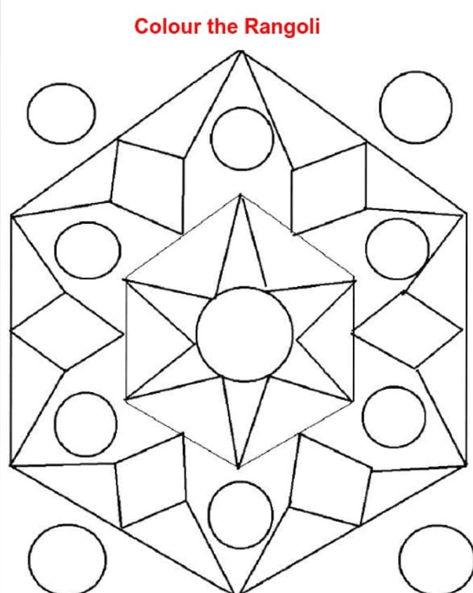

**WORKSHEET**

**MULTIPLE CHOICE QUESTIONS (MCQs)**

**Choose the correct option from the given four options:**

1. Nine crore twelve lakh fifty-seven thousand eight in figures is:
2. 9,12,57,008 (b) 9,12,57,00008 (c) 9,12,57,0008 (d) 9,12,57,08
3. Five hundred nine million six hundred thirty thousand eight hundred thirty-four in figures is:
4. 50,96,30,834 (b) 50,96,13,834 (c) 509,630,834 (d) 509,613,834
5. Number 78,546,919 in words is:
6. Seventy-eight million five hundred forty-six thousand nine hundred nineteen
7. Seventy-eight billion five hundred forty-six thousand nine hundred nineteen
8. Seven crore eighty-five lakh forty-six thousand nine hundred nineteen
9. Seventy-eight crore five hundred forty-six thousand nine hundred nineteen
10. The sum of place values of 4 in the number 34072468 is:
11. 400400 (b) 4000400 (c) 4004000 (d) 4040000
12. The difference of place values of 7 in the number 708567231
13. 699999300 (b) 699300000 (c) 699930000 (d) 699993000
14. The successor of the number 9999999
15. 9999998 (b) 999998 (c) 100000 (d) 10000000
16. The predecessor of the number 100000000 is:
17. 999999999 (b) 99999999 (c) 10000000001 (d) 1000000001
18. The greatest 8-digit number that can be formed using the digits 4,7,0,3,8,2,1,5 if repetition of digits is not allowed:
19. 87534210 (b) 87453210 (c) 87543201 (d) 87543210
20. The smallest 7-digit number that can be formed using the digits 6,5,7,8,9,2,4 without repetition is:
21. 2457869 (b) 2546789 (c) 87543201 (d) 87543210

10. The Hindu-Arabic number for MMDCCLXVII is:

1. 2767
2. 2667
3. 2777
4. 2687

**Subject:-COMPUTER CLASS-V**

1. Make a colourful chart on the topic **Types of Software** and also paste some software picture related to the topic.

**Subject:-ART & CRAFT CLASS-V**

Prepare a craft With the help of ice-cream sticks( Pen stand, Home, Photo Frame, Wall Hanging, Basket)

**Note:**

* **Summer breaks are from 05 May to 23 June 2024. The school**

**reopens on 24 June 2024**

***Have a great Summer Vacation***

**🌸BEAT THE HEAT**

1.Meditate and do simple yoga exercises.

2.Water plants and feed the birds.

3.Join your grandparents and parents for their morning walk.

4.Help your mother in the kitchen.

5.Don’t watch too muchtelevision.

6. Keep your environment in surrounding clean.

7.Plant trees and conserve your natural resources.

8.Build and improve your vocabulary through crosswords, jumble words etc.

9.Solve riddles and puzzles.

10.Read story books and visit places.

11.Improve your reading and writing skills by reading and writing.